Red Team Project

**Summary**

In order to generate deep insights and understand how business decisions impact’s the profitability of the company, we created this analysis that offer valuable information regarding trends, discount impacts, year over year growth and product performance for clothing, bikes, accessories and components, to identify opportunities for growth and optimize business operations.

**Database overview:**

We chose to work with the above tables that generate useful information about our analysis:

* Sales tables: information about sales, dates, quantity per products
* Production tables : information regarding categories, subcategories, standard cost etc.

1. **First, we analysed the total revenue and profitability per year**

  
 Fig.1. YoY Revenue and Profit

This query analyses yearly **revenue** and **profit** for the company, calculates **Year-over-Year (YoY) growth**, and identifies whether a given year contains data for all 12 months or not.

We can see in the analyses that we have an upward in the company’s data starting with year 2013 followed by 2014.

For year 2011 the Previous Year Profit is null or 0.00% , because it doesn’t contain any information to compare with , due to LAG function that was chosen for this query, which compares with the information from the previous year.

Our main findings:

* The 2011 and 2014 are incomplete years;
* The highest profit was achieved in 2014, even the year is incomplete;
* The total revenue increase from year to year;
* 2012 recorded the lowest profit, even though it had high revenues, indicating inefficient financial policies, such as aggressive discounts.
* In 2012, total revenue increased by 165.19 % compared to total revenue of 2011, but profit in 2012 decreased by 41.72% compared to 2011.
* In 2013, total revenue increased by 30.12 % compared to 2012, also the profit increased by 253.76% compared to 2012
* In 2014, total revenue decreased by 54.02% compared to 2013, profit in 2014 increased by 2.63% compared to 2013. But let's keep in mind that the year 2014 is incomplete

2. Next, we analyse **seasonal sales performance** for different **product categories**, providing insights into total revenue, total profit, and average performance metrics for each season and product category.

Also is very important to mention that we chose to analyse only the complete years, 2012 and 2013.

1. we calculated the total revenue and profit over the seasons

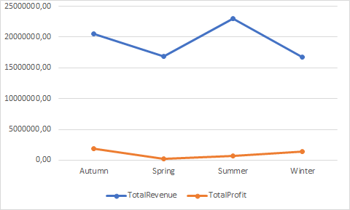

- We can notice that the highest revenues are in the autumn and summer seasons, followed by spring and winter seasons.  
-  The most profitable seasons are Autumn and Winter.

1. Next , we analyse **seasonal sales performance** for different **product categories** by Revenue

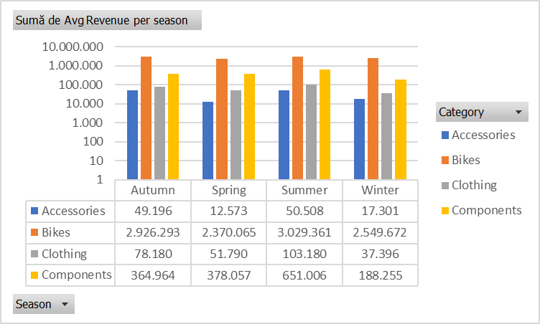  
 Fig.2 – AvgRevenue Per Season  
  
  
  
  
 - Across all seasons, ‘Bikes’ have the best sales and brings the highest **revenue**, with ‘Bikes’ recording values far exceeding those of other product categories.  
- Components brings the second highest revenue, followed by Clothing.  
- All categories brings highest revenue in Summer season.

C. Next , we analyse **seasonal sales performance** for different **product categories** by Profit

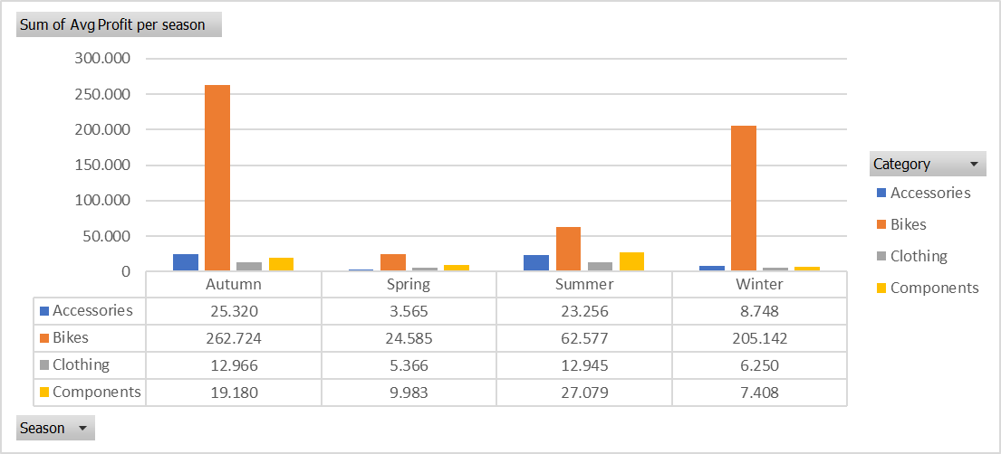

- ‘Bikes’has *the highest profit* in Autumn season followed by Winter, Summer and Spring.

- Also the other product categories have the highest profit in Autumn season.

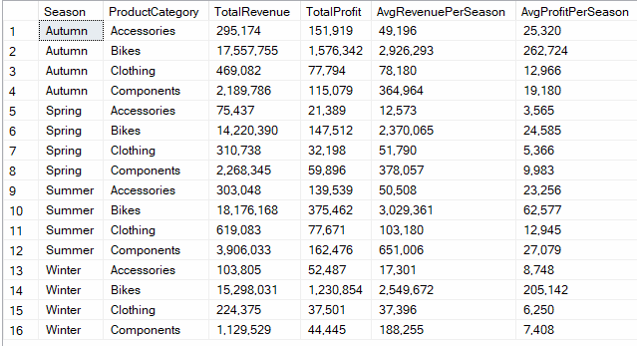

1. Main conclusion : ‘ Bikes’ are the clear leader , with their seasonal trend determining the seasonality of revenues and profits across the entire company. The other product categories have a minimal impact on the company's performance.
2. This query provides a **seasonal sales analysis** by calculating the total quantity of items purchased for each product category (CategoryName) and summarizing it across the four seasons: **Spring**, **Summer**, **Autumn,** and **Winter**.

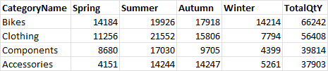  
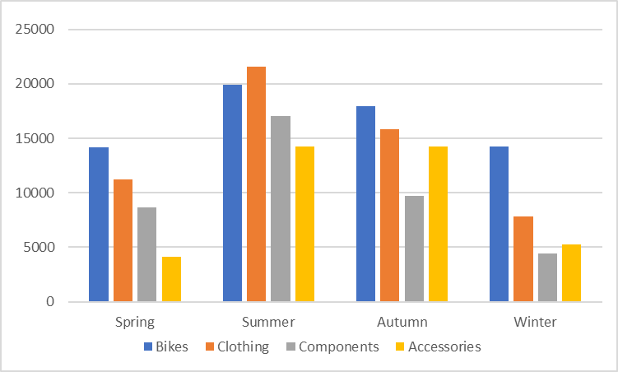

- Overall, **the highest sales occur in Summer** , suggesting increased demand during this season, likely due to preparations for summer activities.

**-**Winter is the **weakest season** for all categories, especially for Components.

-With a total of 66.242 units sold, **Bikes’** represent the category with **the highest sales**, far surpassing the other categories. The highest sales occur in summer (19.926), followed by autumn (17.918), having a lower demand in Spring and Winter.

- Clothing is the second-best selling category, with a balanced distribution.

- ‘Accessories’ and ‘Components’ have a smaller impact, the volume of products ‘Components’ sold (39.814) represents approximately half of the volume sold for Bikes category (66.242)

The following analysis focuses on monthly sales performance segmented by product category (e.g Bikes, Clothing, Accessories, Components) and provides aggregated insights about the quantity of items purchased.

-In 2011, sales began at a relatively low level, but a notable increase in product sales is observed starting the following year.

-In 2013, the growth trend in summer sales becomes more pronounced compared to previous years,

highlighting seasonal patterns.

-Year-over-year growth is evident in total orders and product category sales (e.g.May 2011- 825 total orders , May 2014 -15884 total orders.)

-Irregular sales patterns: certain months in earlier years (e.g. 2011) show no product orders for specigic categories , likely due to underdeveloped product lines or inconsistencies in sales strategies. In 2014, operational challenges such as inventory shortages or distribution delays may have contributed to these gaps. This could also explain the exceptionally high sales observed in March 2014, which recoreded 22,582 total orders.

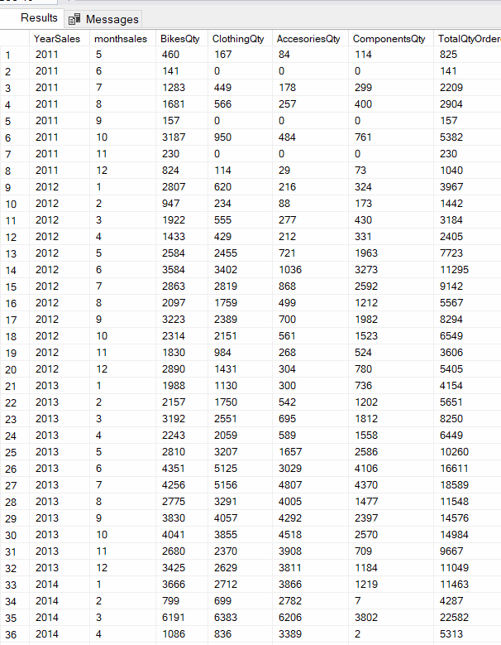



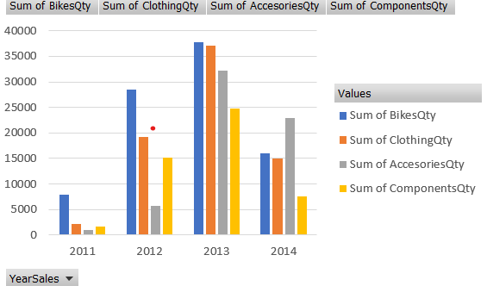

-**we analyze monthly profit during 2011 -2014**  
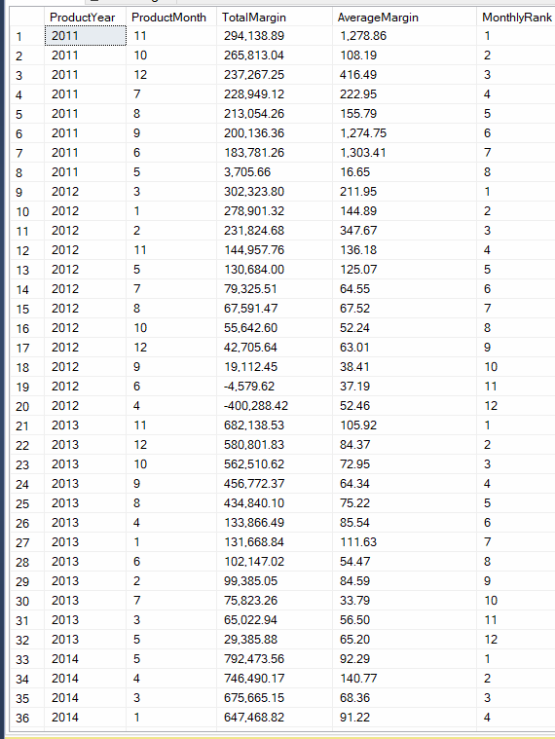



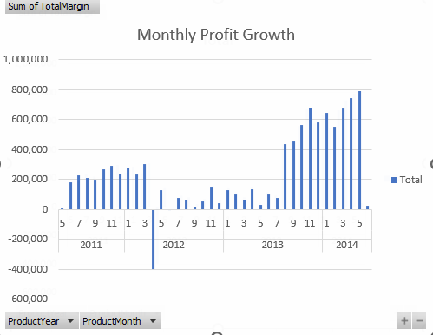

Analysis of Monthly Profit Growth

1. Overall Trend

• The graph demonstrates a clear upward trend in total monthly profit from 2011 to 2014.

• While 2011 and 2012 show relatively low or negative profit margins, there is significant improvement starting in 2013, which continues to grow steadily in 2014.

2. Yearly Comparison

2011:

• Profits are inconsistent, with many months showing losses (negative margins).

• This could be due to the early stages of product development, poor sales, or high operational costs.

2012:

• A slight improvement is visible, but monthly profits remain modest and occasionally dip into negative territory.

• This suggests the company is stabilizing but still facing challenges in maintaining profitability.

2013:

• Significant growth in monthly profits begins to materialize.

• Positive margins dominate, indicating better product performance, higher sales, or improved cost management.

2014:

• Marked by strong and consistent growth, monthly profits are the highest across all years shown.

• This could be attributed to matured product lines, refined business strategies, and operational efficiencies.

3. Seasonal Patterns

• While the graph doesn’t explicitly label months by season, cyclical spikes in profits suggest seasonal trends may play a role.

• Peaks in certain months (e.g., late 2013 and 2014) might coincide with seasonal demand increases or successful promotional campaigns.

This analysis highlights a turnaround from inconsistent profitability in earlier years to strong growth in later years, indicating a company in the process of scaling and optimizing its business strategies.

Based on the previous analysis, where we observed that certain months generate the highest profits (January, February, March - 2012; October, November, December - 2011 and 2013), we make an analyze of **the quarterly profit**

-the dominance of Q4 and Q1 in terms of total margins suggests a **seasonal trend** in the company's business cycle. These quarters may align with strategic company initiatives to maximize profits during these periods.

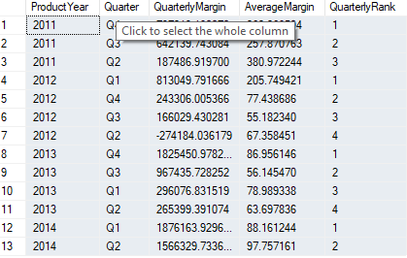

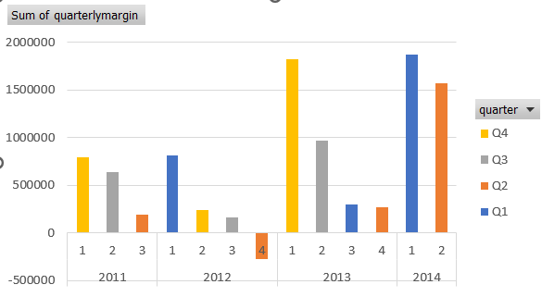

To conduct a meaningful data analysis based on the graph and data displayed, here’s an analysis for the image:

Looking at the data overall, there is a clear seasonal pattern. Q4 is often the strongest quarter, as seen in 2011, 2012, and 2013, likely due to higher sales during holidays or promotional periods. Q1 also performs well in some years, such as 2012 and 2014, possibly because of leftover sales momentum from the holidays. Q2 and Q3 are usually weaker quarters, showing slower sales during these periods. This seasonal behavior can help guide sales strategies, focusing on maximizing resources during Q4 and improving performance in the middle quarters of the year.

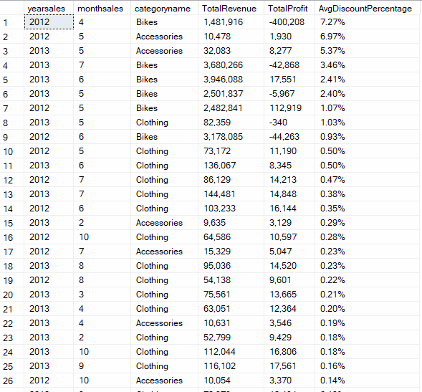

This query calculates **monthly sales performance** for each product category in the years **2012** and **2013**, focusing on categories with a significant **average discount** (greater than 0.01%). It outputs **total revenue, total profit, and average discount percentage**, sorted by the highest discount percentage.

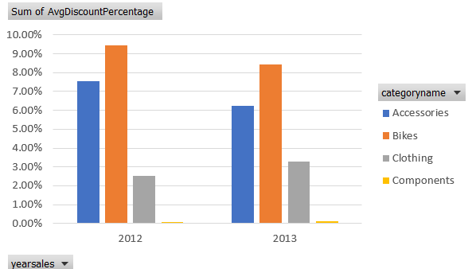

**Recommendations:** Based on our analysis we noticed that there is an upward trend in the company’s data over the years and months. In 2012 we can see that the profit significantly dropped generating negative margin in Q2.( caused by the aggressive discounts applied). The drop in total discounts to 12.71% in 2013 suggests that the company managed to recover from the aggressive discounting strategy of the previous year. They may have focused more on keeping margins healthy and not relying as much on discounts to drive sales.

In order to boost the profit for the company, they should take into consideration the following recommendation:

* + 1. Pay attention on the discounts applied for the products, as we can see in year 2012, when a high level of discount generated a negative profit for the company.
    2. The profitability of discounts can vary by category. For example, categories like "Bikes" show strong **profit retention** despite discounts, making them a valuable focus area. However, categories like "Clothing" may require a closer look to ensure that the discounts aren’t excessively cutting into margins. A pricing optimization strategy may be necessary to balance **sales volume** and **profitability.**
    3. Leverage High-Performing Discount Strategies. For categories where high discounts correlate with strong revenue and profit, continue using targeted promotions during key months.
    4. If discounts are concentrated in specific months (e.g., November-December), ensure sufficient **inventory** and **marketing efforts** are aligned with those periods.  
       Consider extending successful campaigns to adjacent months to stabilize revenue.
    5. Use the TotalProfit metric to identify categories that are both profitable and scalable.

Example: If "Bikes" consistently contribute the most profit, allocate more resources to expanding this category.